DINE Magazine is distributed in National Newspapers, High End Toronto Hotels, Reception Areas, Air Canada Maple Leaf Lounges, VIA Rail Lounges, Top Hotel Rooms & Suites in cities across Canada and more!

Advertising in Dine & Destinations Magazine gives you the ultimate exposure to your market!

DINE appeals to savvy food lovers who enjoy travel, a luxury lifestyle and the thrill of discovering new dining experiences.

It has been the foremost Destination Dining Guide in Canada for over 10 years!

I only have a few spots available! Secure your spot as soon as possible as we will sell out of space fast!



**ADVERTISING SPACE AVAILABLE IN THE LUXURIOUS ANNUAL DINE AND DESTINATIONS MAGAZINE!**

**SARA WAXMAN’S HIGH END DINING, TRAVEL AND LIFESTYLE MAGAZINE**

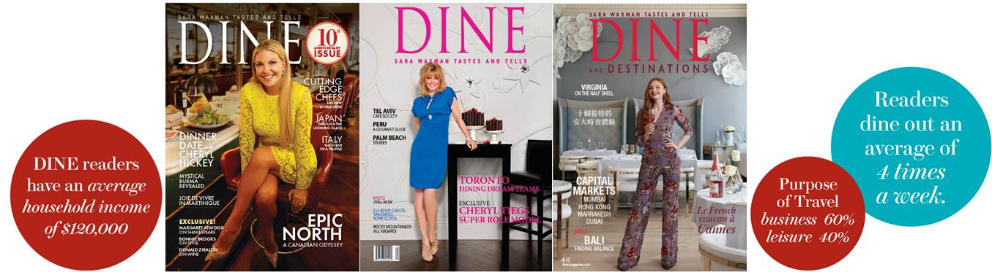

DINE and Destinations celebrates unique stories from coast to coast that will entice you to explore our home and native land.

We will continue to surprise you with features from distant lands.

In every story, we answer your all important questions:

* What’s the best place to eat?
* What’s the best place to stay?
* What are the exciting “off the beaten track experiences?”

DINE and Destinations is for the discerning food lover and travel enthusiast who enjoys dining out around the world. DINE is the leading magazine for active food lovers who enjoy the dining out experience. We bring together appropriately matched readers and advertisers through our focused distribution. Food, wine, travel and hospitality bring people together in the most amicable ways. Our distribution is focused on these people – readers who have a strong interest in what we have to say. Besides those who use DINE Magazine as a dining guide, there are a significant number of people who simply enjoy reading about food, wine and travel. Our experience is that hotel guests use DINE as a guide when visiting Toronto, and then take it with them to their home cities and countries as a souvenir, thereby adding to the total readership. Your message gets directly to the people you want to reach, in a way that they find pleasing to receive. DINE and Destinations is distributed in the National Newspapers, High End Toronto Hotels, Reception Areas, Air Canada, Air France and Air Transat Lounges, VIA Rail Lounges, Top Hotel Rooms & Suites in cities across Canada. Also distributed Internationally in Air Canada Maple Leaf Lounges in New York, Los Angeles, London, Paris and Frankfurt, as well Canadian Consulates in the US and Hong Kong.

Call BNL to secure your spot today!

[www.dinemagazine.ca](http://click.icptrack.com/icp/relay.php?r=26658293&msgid=509226&act=OI8K&c=1362351&destination=http%3A%2F%2Fwww.dinemagazine.ca) (12613)